How to Change User Name

Author: Daniel
Reviewer：Eason

Account
Issue introduction
Change the name of the user.
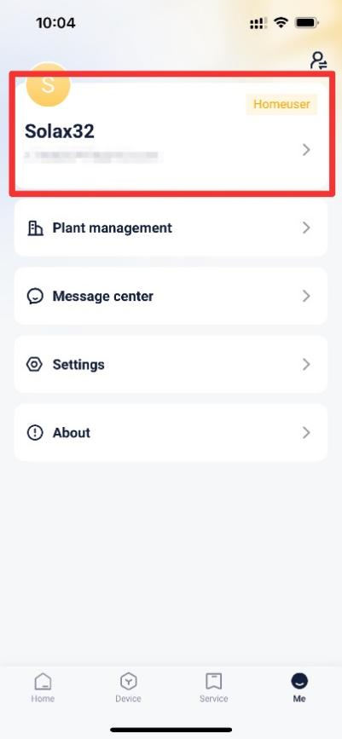
Operation guidance
Step1: Go to <Account information> to Change the user name.
Setting path：Me→Account information→User name

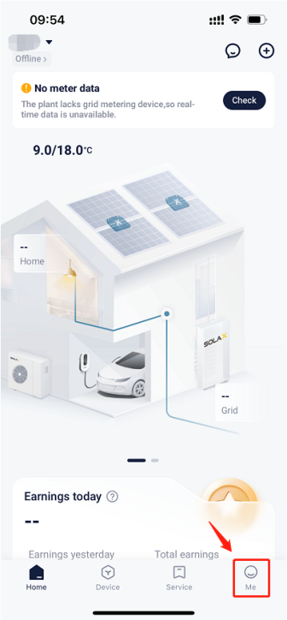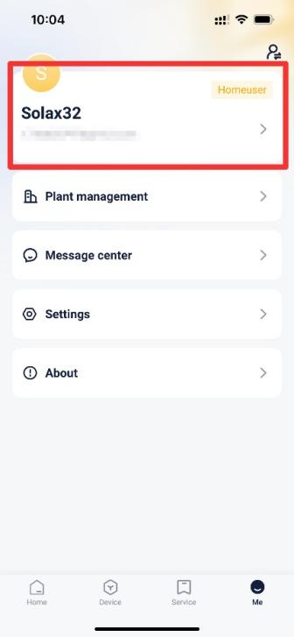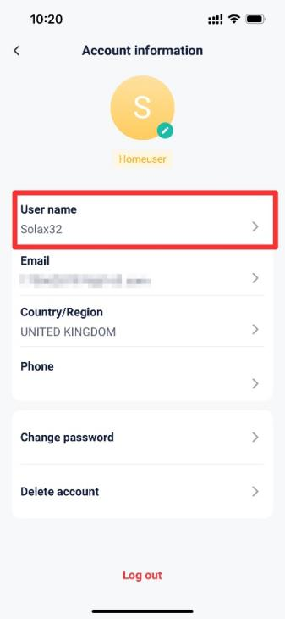
Step2: Enter the password and the new user name, then save the settings.
Setting path：Password→User name→Save
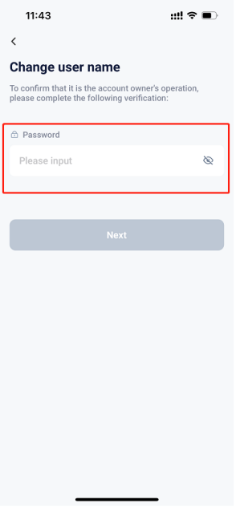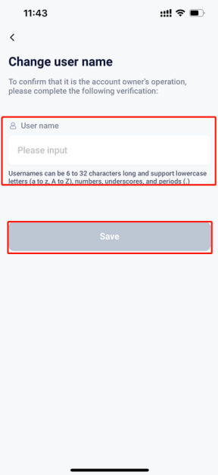
Please note
- Some special characters may prevent successful saving
- If the settings save fails, please check your mobile network, ensure a stable connection, log out of your account, and then log back in. Follow the steps above to make the changes.

